[Name of Customer Agency]

CHANGE MANAGEMENT plan

  - [Program Name]

Version 1.0

[Day, Month, Year]

  - Document History

Release No. | Date | Author | Revision Description
1.0 |  |  | Initial Draft Version

I have carefully assessed the Change Management Plan for the <<INSERT NAME OF PROGRAM>>. This document has been completed in accordance with the requirements of the Office of Shared Solutions and Performance Improvement (OSSPI) Guidance.

MANAGEMENT CERTIFICATION - Please check the appropriate statement.

______ The document is accepted.

______ The document is accepted pending the changes noted.

______ The document is not accepted.

We fully accept the content within this project artifact and associated tasks.

_______________________________ _____________________
<<Insert Name>> <<Insert Date>>
<<Insert Title>>

_______________________________ _____________________
<<Insert Name>> <<Insert Date>>
<<Insert Title>>

Contents
Contents 4
1. Purpose of Plan 5
2. Definition of Change Scope 6
3. Roles & Responsibilities 7
4. Change Management Assessment 8
5. Change Management Strategies 9
6. Change Management Project Timeline 10
7. Operations & Maintenance (O&M) 11
8. Approvals 12
Appendix A: Key References 13
Appendix B: Key Terms 13

Purpose of Plan
<<This document should be reviewed and approved by both the Customer Program Manager.

This Change Management Plan is intended to accomplish the following:
- Establish a clearly defined definition and intended outcome of the change;
- Establish clearly defined roles and responsibilities;
- Establish a clear level of change required for the initiative;
- Establish recommended change management strategies a structured change to shift individuals, teams, and organizations from the current state to the desired state; and
- Establish a project timeline to implement change management strategies.>>

Definition of Change Scope

<<Provide a clear background and overview of the change project, what overall organizational and/or personnel changes are anticipated, impacted audiences and stakeholders as outlined in the Change Readiness Assessment, as well as any other additional details supporting stakeholders should need to understand the Change Management Plan.>>

Roles & Responsibilities

<<Provide an overview of the roles and responsibilities of the Program Management Office (PMO) and other affiliated internal project stakeholders as it relates to the planning, execution, support, and management of the change initiative. These roles can be defined in terms of project awareness, project subject matter experts, functional change implementation, providing advocacy and action, and/or stakeholder support.>>

Change Management Assessment

<<Assess and align your change initiative with the Change Management continuum based on the desired results and magnitude of the change. Review the recommended Change Management activities for each audience based off of their impact and Change Readiness outcome.

The Change Management continuum is a useful way to indicate how a change would require change management activities and gain support from senior leaders to include it in the project plans. >>

Change Management Continuum
Desired Results | Incremental | Defined Area | Structural Change | Radical Change
Magnitude of Change | Little impact on business processes, jobs, or organizational structure  No impact on personal/cultural | Minor impacts on business processes, jobs, or organizational structure  Minor impact on organizational structure | Significant impacts on business processes, jobs, or organizational structure  Significant impact on personal/ cultural | Transformation of business processes, jobs, or organizational structure  Major impact personal/ cultural
Typical Change Management Activity | - Training  - Communication | - Same +  - Process re-engineering  - Change Readiness Assessment | - Same +  - Leadership agreements  - Risk assessment  - Organizational alignment plans  - Transition plans | - Same +  - Full scale Business process re-engineering  - ROI Analysis

Change Management Strategies

<<Outline and detail targeted change management strategies based on the Change Management Continuum outcome. Post Change Project recommendations would include conducting a change adoption survey, conducting post project evaluations, and/or evaluating the change impact.

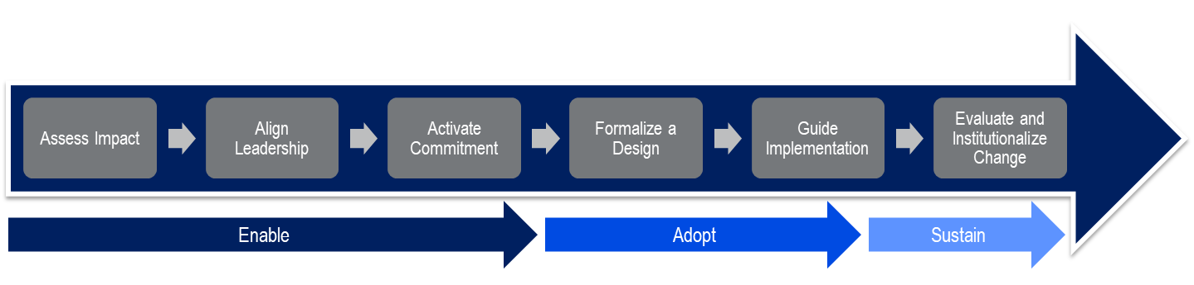
All strategies should focus on the enablement, adoption, and sustainment of the change initiative as outlined in the process below.>>

Change Management Project Timeline

<<Develop an implementation timeline of the change management strategies as they correspond with the overall change initiative timeline.>>

Operations & Maintenance (O&M)

<<Detail out strategies for planned and/or immediate impacts from O&M on processes and timing. This should include what O&M change is occurring, when, who it impacts, how great the impacts are, and what that means for the user.>>

Approvals
<<Identify the required signatures or approvals for the Change Management Plan below.>>

Appendix A: Key References
<<Insert the name, version number, description, and physical location of any documents referenced in this document. Add rows to the table as necessary.>>

Table below summarizes the documents referenced in this document.

Document Name | Description | Location
<<Document Name and Version Number>> | <<Document description>> | <<URL to where document is located>>
Table 2: Key References

Appendix B: Key Terms
Table below provides definitions and explanations for terms and acronyms relevant to the content presented within this document.

Term | Definition
<<Insert Term>> | <<Provide definition of term and acronyms used in this document>>
Table 3: Key Terms

